1. Huffman code for encoding and decoding :

Program :

input_data = 'AABCBAD';

input_data = upper(input_data);

disp("The unique symbols are :")

symbols = unique(input_data);

disp(symbols)

freq = histcounts(double(input_data), [double(symbols) max(double(input_data))+1]);

disp("The frequency are :")

disp(freq);

probabilities = freq / sum(freq);

[dict,avglen]=huffmandict(double(symbols),double(probabilities));

disp("The huffman dictionary are :")

disp(dict);

encoded_data = huffmanenco(input_data, dict);

disp('Encoded Data: ');

disp(encoded_data);

decoded_data = huffmandeco(encoded_data, dict);

% Display decoded data

fprintf('Decoded Data: %s\n', char(decoded_data));

**********************************************************End************************

Output:

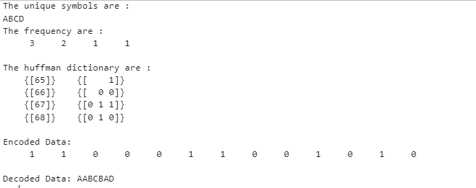

2. Hamming encoding and decoding

data=[0 1 1 0];

disp("Origignal Data");

disp(data);

encodedData=hammingEncode(data);

disp("Encoded Data 7 bits");

disp(encodedData);

recievedData=encodedData;

recievedData(3)=mod(recievedData(3)+1,2);

disp("Recieved Data with error");

disp(recievedData);

[correctedData,correctedCode]=hammingDecode(recievedData);

disp("Corrected Data");

disp(correctedData);

disp("Corrected code 7 bits");

disp(correctedCode);

function encoded=hammingEncode(data)

if length(data)~=4

error("Input data must be 4 bit binary vector");

end

G=[1 0 0 0 1 1 0;

0 1 0 0 1 0 1;

0 0 1 0 0 1 1;

0 0 0 1 1 1 1];

encoded=mod(data*G,2);

end

function[correctedData,correctedCode]=hammingDecode(recieved)

if length(recieved)~=7

error("Recieved code must be 7 bits binary vector")

end

H=[ 1 1 0 1 1 0 0;

1 0 1 1 0 1 0;

0 1 1 1 0 0 1];

syndrome=mod(H*recieved',2);

if any(syndrome)

errorPos=bi2de(syndrome',"left-msb");

fprintf("Error detecdted at bit position:%d\n",errorPos);

recieved(errorPos)=mod(recieved(errorPos)+1,2);

else

disp("No errors detected.");

end

correctedCode=recieved;

correctedData=recieved(1:4);

end

output:

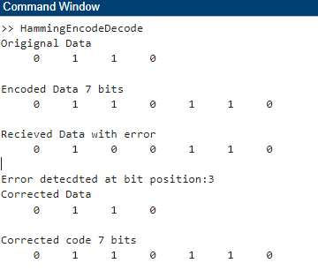

3. Convolution encoding and decoding

data=[1 1 0];

disp("original Data");

disp(data);

encodedData=convEncode(data);

disp("Encoded data (rate 1/2):");

disp(encodedData);

%simulate noicy channel

noicyData=encodedData;

noicyData(3)=mod(noicyData(5)+1,2);

decodedData=viterbiDecode(noicyData);

disp("Decoded Data :")

disp(decodedData);

% function for encode

function encoded=convEncode(data)

state=[0 0];

encoded=[];

%loop each input bit

for i=1:length(data)

state=[data(i) state(1:2)];

output1=mod(state(1)+state(2)+state(3),2);

output2=mod(state(1)+state(3),2);

%Append the output message to encoder

encoded=[encoded output1 output2];

end

end

% function for decoding

function decoded=viterbiDecode(encoded)

trellis=poly2trellis(3,[7,5]);

decoded=vitdec(encoded,trellis,2,"trunc","hard");

end

output:

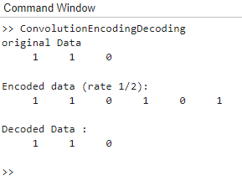

**4. Gram-schmidt orthogonalization.**

***File name : gramSchmidtOrthogonalBasis.m***

function orthogonal_basis = gramSchmidtOrthogonalBasis(vectors)

% Input: vectors - a matrix where each column is a vector (n x m matrix)

% Output: orthogonal_basis - a matrix of orthogonal basis vectors

[n, m] = size(vectors); % n is the dimension, m is the number of vectors

orthogonal_basis = zeros(n, m); % Initialize the orthogonal basis matrix

for i = 1:m

% Start with the original vector

orthogonal_vector = vectors(:, i);

% Subtract projections of previous orthogonal vectors

for j = 1:i-1

orthogonal_vector = orthogonal_vector - (dot(orthogonal_basis(:, j), vectors(:, i)) / dot(orthogonal_basis(:, j), orthogonal_basis(:, j))) * orthogonal_basis(:, j);

end

% Store the orthogonalized vector

orthogonal_basis(:, i) = orthogonal_vector;

end

% Remove any zero columns (if vectors were linearly dependent)

orthogonal_basis = orthogonal_basis(:, any(orthogonal_basis));

end

*******************************************************************************

***file name : orthogonal.m***

vectors=[1 1 0;1 0 1;0 1 1];

orthogonal_basis=gramSchmidtOrthogonalBasis(vectors);

% gramSchmidtOrthogonalBasis this function is called by another file(gramSchmidtOrthogonalBasis.m) with

% name as the function name

disp('orthogonal vectors are:')

disp(orthogonal_basis);

% Orthonormal function starts from here

% Given set of vectors (Example input as columns)

A = [1 1 0;1 0 1;0 1 1]; % 3 vectors in 3D space

% Number of vectors (columns in A)

[m, n] = size(A);

% Initialize matrix to store the orthonormal vectors

Q = zeros(m, n);

% Gram-Schmidt Process to generate orthonormal basis

for i = 1:n

% Start with the current vector in the input set

v = A(:, i);

% Subtract projections onto the previous orthonormal vectors

for j = 1:i-1

v = v - (Q(:, j)' * A(:, i)) * Q(:, j);

end

% Normalize the resulting vector to make it unit length

Q(:, i) = v / norm(v);

end

% Output the orthonormal vectors (columns of Q)

disp('Orthonormal Vectors (columns of Q):');

disp(Q);

% Plot the orthonormal vectors (for 3D case in this example)

figure;

hold on;

axis equal;

grid on;

xlabel('X');

ylabel('Y');

zlabel('Z');

title('Orthonormal Vectors');

% Plot each orthonormal vector

for i = 1:n

quiver3(0, 0, 0, Q(1, i), Q(2, i), Q(3, i), 0, 'LineWidth', 2, 'DisplayName', ['v' num2str(i)]);

end

% Add legend

legend show;

hold off;

*********************************************

output:

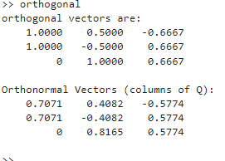

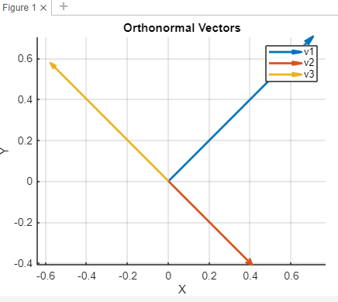

*************************************************************************************

**Simulation bit error rate for AWGN channel**

% Parameters

N = 1e5; % Number of bits

EbN0_dB = 0:6; % Eb/N0 range in dB

M = 2; % Binary modulation (BPSK)

k = log2(M); % Bits per symbol

% Generate random binary data

data = randi([0 1], N, 1);

% BPSK modulation

txSignal = 2*data - 1; % Map 0 -> -1, 1 -> 1

% Rectangular pulse shaping

pulseShape = ones(1, 1); % Rectangular pulse

txSignal = conv(txSignal, pulseShape, 'same');

% Initialize BER array

BER = zeros(length(EbN0_dB), 1);

for i = 1:length(EbN0_dB)

% Calculate noise variance

EbN0 = 10^(EbN0_dB(i)/10);

noiseVar = 1/(2*EbN0);

% Generate AWGN noise

noise = sqrt(noiseVar) * randn(size(txSignal));

% Received signal

rxSignal = txSignal + noise;

% BPSK demodulation

rxData = rxSignal > 0;

% Calculate BER

BER(i) = sum(data ~= rxData) / N;

end

% Plot BER vs Eb/N0

figure;

semilogy(EbN0_dB, BER, 'o-');

xlabel('Eb/N0 (dB)');

ylabel('Bit Error Rate (BER)');

title('BER vs Eb/N0 for BPSK in AWGN Channel');

grid on;

output:

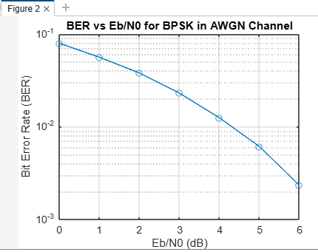

***************************************AWGN END***********************************

CRC:

function crc_code = crc_ccitt(data)

% CRC-CCITT polynomial

poly = hex2dec('1021');

crc = uint16(0xFFFF); % Initial value

for i = 1:length(data)

crc = bitxor(crc, bitshift(uint16(data(i)), 8));

for j = 1:8

if bitand(crc, 32768) % 0x8000

crc = bitxor(bitshift(crc, 1), poly);

else

crc = bitshift(crc, 1);

end

end

end

crc_code = bitand(crc, 65535); % 0xFFFF

end

% Example data

data = uint8('123456789');

crc_code = crc_ccitt(data);

fprintf('CRC Code: %04X\n', crc_code);

% Verification without error

data_no_error = uint8('123456789');

crc_no_error = crc_ccitt(data_no_error);

fprintf('Verification without error: %s\n', isequal(crc_code, crc_no_error));

% Verification with error

data_with_error = uint8('123456780');

crc_with_error = crc_ccitt(data_with_error);

fprintf('Verification with error: %s\n', isequal(crc_code, crc_with_error));

output:

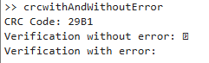

****************************************End**********************

**16 QAM Modulation:**

% MATLAB R2015 code for 16-QAM modulation and constellation diagram

% Parameters

M = 16; % Modulation order (16-QAM)

k = log2(M); % Bits per symbol

nSymbols = 1000; % Number of symbols

% Generate random data

data = randi([0 M-1], nSymbols, 1);

% QAM Modulation (normalize symbols for unit average power)

modulatedSignal = qammod(data, M); % Perform QAM modulation

modulatedSignal = modulatedSignal / sqrt(mean(abs(modulatedSignal).^2)); % Normalize to unit power

% Constellation Plot

scatterplot(modulatedSignal);

title('16-QAM Constellation (R2015)');

xlabel('In-Phase');

ylabel('Quadrature');

% Adding grid and axis labels for better visualization

grid on;

axis([-1.5 1.5 -1.5 1.5]);

output:

